**Using AI for Face Mask Detector Alarm System - A Research Study**

*A project submitted in partial fulfilment of the*

*Requirements for the award of the degree of*

**Bachelor of Technology**

**in**

**COMPUTER SCIENCE AND ENGINEERING**



Submitted by:

**Mr. Venkatarami Reddy**

Roll No.: 12011041

Supervised by:

**Dr. Mukesh Mann**

Assistant Professor

**INDIAN INSTITUTE OF INFORMATION TECHNOLOGY**

**SONEPAT-131201, HARYANA, INDIA**

# ACKNOWLEDGEMENTS

In the present world of competition there is a race of existence in which those are having will to come forward succeed. Project is like a bridge between theoretical and practical working. With this willing I joined this particular project. First of all, I would like to thank the supreme power the Almighty God who is obviously the one has always guided me to work on the one has always guided me to work on the right path of life. Without his grace this project could not become a reality. Next to him are my parents, whom I am greatly indebted for me brought up with love and encouragement to this stage. I am feeling oblige in taking the opportunity to sincerely thanks to **Dr. M. N. Doja** (Director of IIIT Sonepat) and special thanks to my worthy teacher of Computer Science **Dr. Mukesh Mann**. Moreover, I am highly obliged in taking the opportunity to sincerely thanks to all the staff members of CSE department for their generous attitude and friendly behaviour. At last but not the least I am thankful to all my teachers and friends who have been always helping and encouraging me though out the year. I have no valuable words to express my thanks, but my heart is still full of the favours received from every person

**Venkatarami Reddy (12011041)**

# SELF DECLARATION

I hereby declare that work contained in the research titled “**Using AI for Face Mask Detector Alarm System - A Research Study**” is original. I have followed the standards of project ethics to the best of my abilities. I have acknowledged all sources of information which I have used in the project.

Name: Venkatarami Reddy

Roll No.: 12011041

Department of Computer Science and Engineering,

Indian Institute of Information Technology,

Sonepat-131201, Haryana, India.

# CERTIFICATE

This is to certify that **Mr. Venkatarami Reddy** has worked on the research entitled “**Using AI for Face Mask Detector Alarm System - A Research Study**” under my supervision and guidance.

The contents of the project, being submitted to **Department of Computer Science and Engineering, IIIT, Sonepat,** for the award of the degree of **B. Tech in Computer Science and Engineering,** are original and have been carried out by the candidate himself. This project has not been submitted in full or part for the award of any other degree or diploma to this or any other university.

Dr. Mukesh Mann Supervisor

Department of Compute Science and Engineering, Indian Institute of Information Technology , Sonepat-131201, Haryana, India.

# ABSTRACT

Facial recognition, as a biometric system, is a crucial tool for the identification procedures. When using facial recognition, an individual’s identity is identified using their unique facial features. Biometric authentication system helps in identifying individuals using their physiological and behavioral features. Physiological biometrics utilize human features such as faces, irises, and fingerprints. In contrast, behavioral biometric rely on features that humans do, such as voice and handwritings. Facial recognition has been widely used for security and other law enforcement purposes. However, since **COVID-19** pandemic, many people around the world had to wear face masks. This thesis introduces a neural network system, which can be trained to identify people’s facial features while half of their faces are covered by face masks. The Convolution Neural Network (CNN) model using transfer learning technique has achieved remarkable accuracy even the original dataset is very limited. One large face mask detection dataset was first used to train the model, while the original much smaller Face Mask Detector dataset was used to adapt and fine-tune this model that was previously generated. During the training and testing phases, network structures, and various parameters were adjusted to achieve the best accuracy results for the actual small dataset.

*Keywords:* Biometrics, Facial Recognition, Face Mask Detection, Convolution Neural Network, Transfer learning.

Name of the student: **Venkatarami Reddy**

Roll No.: 12011041

Degree for which submitted: **B. Tech,** Department of **Computer Science and**

**Engineering, IIIT Sonepat**

Project Title: **Using AI for Face Mask Detector Alarm System - A Research Study**

Name of the project Supervisor: **Dr. Mukesh Mann**

Month and Year of report submission: **October 2021**

|  |  |
| --- | --- |
| Acknowledgments | i |
| Self Declaration | ii |
| Certificate | iii |
| Abstract | iv |
| List of Abbreviations | v |
| List of Figures | vi |
| List of Tables and Equations | vii |
| Table of Contents | viii |

**List of Abbreviations**

|  |  |
| --- | --- |
| **CNN** | **Convolutional Neural Network** |
| **FMD** | **Face Mask Detector** |
| **AI** | **Artificial Intelligence** |
| **ML** | **Machine Learning** |
| **FR** | **Face Recognition** |
| **DL** | **Deep Learning** |

## **List of Figures**

|  |  |  |
| --- | --- | --- |
| ***Figure’s***  ***No.*** | **Name of Figures** | ***Page Nos.*** |
| ***Figure 1*** | *Design of Face Mask Detector* | ***06*** |
| ***Figure 2*** | *People Wearing Face Masks* | ***07*** |
| ***Figure 3*** | *People not Wearing Face Masks* | ***07*** |
| ***Figure 4*** | *PYTHON Language* | ***08*** |
| ***Figure 5*** | *Jupyter Notebook* | ***08*** |
| ***Figure 6*** | *GitHub* | ***09*** |
| ***Figure 7*** | *TensorFlow* | ***09*** |
| ***Figure 8*** | *Keras* | ***10*** |
| ***Figure 9*** | *Matplotlib* | ***10*** |
| ***Figure 10*** | *Numpy* | ***10*** |
| ***Figure 11*** | *OpenCV* | ***11*** |
| ***Figure 12*** | *Fine-Tuning Stepa* | ***13*** |
| ***Figure 13*** | *Loading the Datasets* | ***14*** |
| ***Figure 14*** | *Training and Compiling* | ***14*** |
| ***Figure 15*** | *Accuracy Results* | ***16*** |
| ***Figure 16*** | *Plot of Results During Training* | ***16*** |
| ***Figure 17*** | *Testing the Trained Model* | ***17*** |
| ***Figure 18*** | *Detecting the Face Mask Using OpenCV* | ***18*** |
| ***Figure 19*** | *Mask Detector with no Mask* | ***19*** |
| ***Figure 20*** | *Mask Detector with Mask* | ***19*** |
| ***Figure 21*** | *Features of Face Mask Detector* | ***20-22*** |

## **List of Tables**

|  |  |  |
| --- | --- | --- |
| ***Table***  ***No.*** | **Name of Figures** | ***Page Nos.*** |
| ***Table 1*** | *Epoch Number and Loss Percentage Results* | ***15*** |

## 

## **List of Equations**

|  |  |  |
| --- | --- | --- |
| ***Equation***  ***No.*** | **Name of Figures** | ***Page Nos.*** |
| ***Equation 1*** | *Supervised Learning Algorithm Equation* | ***12*** |

|  |  |  |  |
| --- | --- | --- | --- |
| **TABLE OF CONTENTS** | | | **Pg. No** |
| C  H  A  P  T  E  R  01 | **Introduction** | | **01** |
| **1.1** | Introduction | **01** |
| **1.2** | Problem Outline | **02** |
| **1.2.1** | Purpose of Project | **02** |
| **1.2.2** | Project Description | **03** |
| **1.2.3** | Project Objectives | **04** |
| **1.3** | Summary | **04** |
| C  H  A  P  T  E  R  02 | **Literature Review** | | **05** |
| **2.1** | Face Mask Detector | **05** |
| **2.2** | Face Detection Techniques | **05** |
| **2.3** | Multi-Stage CNN Architecture for Face Mask Detection | **05** |
| **2.4** | Real Time Face Mask Detection with Alarm System using DL | **05** |
| C  H  A  P  T  E  R  03 | **Methodology** | | **06** |
| **3.1** | System Design | **06** |
| **3.2** | Datasets | **06** |
| **3.3** | Development Platform Tools | **08** |
| **3.4** | Libraries Used | **09** |
| **3.5** | Summary | **11** |
| C  H  A  P  T  E  R  04 | **Training and Testing** | | **12** |
| **4.1** | Data PreProcessing | **12** |
| **4.2** | Supervised Learning | **12** |
| **4.3** | Transfer Learning | **13** |
| **4.4** | Training and Fine Tuning | **13** |
| **4.5** | Running Epochs and Accuracy | **15** |
| **4.6** | Testing | **17** |
| C  H  A  P  T  E  R  05 | **Results And Discussions** | | **19** |
| **5.1** | Result on Testing | **19** |
| **5.2** | Some Features of Face Mask Detector | **20** |
| **5.3** | Multiple Mask Detection | **22** |
| **5.4** | Summary | **23** |
| C  H  A  P  T  E  R  06 | **Conclusion and Future Scope** | | **24** |
| **6.1** | Limitations | **24** |
| **6.2** | Scope of the Project | **25** |
| **6.3** | Future Goals | **25** |
| **6.4** | Conclusion | **27** |
| **References** | | | **26-27** |

**CHAPTER 01**

**Introduction**

* 1. **Introduction**

The trend of wearing face masks in public is rising due to the COVID-19 coronavirus epidemic all over the world. Before Covid-19, People used to wear masks to cover their health from air pollution. While other people are tone-conscious about their aesthetics, they hide their passions in the public to hide their faces. Further than five million cases were infected by COVID19 in lower than 6 months across 188 countries. The contagion spreads through close contact and in crowded and overcrowded areas. We can attack and predict new conditions by the help of new Technologies analogous as artificial intelligence, Iot, Big data, and Machine knowledge. In order to more understand infection rates might be drop through our fashion.

People are forced by laws to wear face masks intimately in numerous countries. These rules and laws were developed as an action to the exponential growth in cases and deaths in numerous areas. Still, the system of covering large groups of individualities is getting harder intimately areas. So we'll produce a robotization process for detecting the faces.

The distinctive face features of each existent in a face mask condition will give us a chance in identifiying the person fluently and in an automated way. Recent rapid-fire- fire- fire technological inventions in deep knowledge and computer vision have presented openings for development in numerous fields. As the main element of deep knowledge styles, deep neural networks (DNNs) have demonstrated superior performance in numerous fields, including object discovery, image type, image segmentation, and distancing discovery. One primary model of DNNs is Mobile Net, Mobile Net is a CNN armature model for Image Bracket and Mobile Vision. There are other models also but Mobile Net takes less computation power to apply transfer knowledge to. This makes it a perfect fit for Mobile bias, bedded systems and computers without GPU or low computational effectiveness with compromising significantly with the delicacyoftheresults.it is also swish suited for web cybersurfers as cybersurfers have limitation over calculation, graphic processing and storage.

#### **Mobile Net Architecture**

* Mobile Nets for mobile and embedded vision applications is proposed, which are based on a streamlined architecture that uses depth wise separable convolutions to build light weight deep neural networks.
* Two simple global hyper-parameters that efficiently trade off between latency and accuracy are introduced.

The core layer of Mobile Net is depth wise separable filters, named as Depth wise Separable Convolution. The network structure is another factor to boost the performance. Finally, the width and resolution can be tuned to trade off between latency and accuracy.

So Having High Accuracy and validation accuracy we will use Mobile Net for training our model later in the section we will also compare accuracy, validation accuracy, loss, validation loss in CNN and Mobile Net.

* 1. **Problem Outline**

Coronavirus (COVID-19) is an emerging respiratory infectious disease caused by severe acute

respiratory syndrome coronavirus 2 (SARS-CoV2). At present, COVID-19 has rapidly spread

to the majority of countries worldwide affecting more than 14.9 million individuals, and

has caused 618,017 deaths, reported by the World Health Organization (WHO) on

23 July 2020. **To avoid globaltragedy, a practical and straightforward approach to**

**precluding the spread of the contagion is urgently needed worldwide**. Former studies have

proved the fact tha facemask-wearing is a very effective method in preventing the spread of

respiratory viruses. For instance, the efficiencies of N95 and surgical masks in preventing

the transmission of SARS are 91% and 68%, respectively Facemask- wearing can intrude

airborne contagions and patches effectively, similar that these pathogens can no enter the

respiratory system of another person. As a non- medicinal intervention, facemask- wearing

is an effective and cheap system to decrease the rate of mortality and morbidity from

respiratory virus and infections. Since the outbreak of COVID-19, facemasks have been

routinely used by the general public to reduce exposure to airborne pathogens in numerous

countries. In addition to cases suspected of factual infection with COVID-19 being needed to

wear facemasks for the forestallment of contagion spreading, healthy persons also need to

wear facemasks to cover themselves from infection. Facemasks, when worn properly, will

effectively prevent the forward instigation of micro-particles of the virus when expelled

from a cough or sneeze, precluding complaint transmission. Still, the effectiveness of

facemasks in containing the spread of airborne conditions in the general public has been

lowered, substantially due to indecorous wearing. Thus, it's necessary to develop an automatic

discovery approach for facemask- wearing conditions, which can contribute to particular

protection and public epidemic forestallment. The distinctive facial characteristics of a face

of each person and the algoritms applied for detecting facemask- wearing conditions give us

a chance for automatic identification.

* + 1. **Purpose of Project**

COVID-19 has disintegrated normal life each over the Earth and disturbed humans’ life

drastically. Also, it has taken the lives of numerous people and numerous are floundering

with its symptoms. This is a respiratory contagion and spread through respiration of

COVID-19 Contagion through the nose while inhalation in the polluted terrain. Former

studies have plant that facemask- wearing is precious in precluding the spread of

respiratory contagions. For case, the edge of N95 and surgical masks in facemask-

wearing conditions, which can contribute to particular protection and public epidemic

forestallment.

Face mask Discovery refers to descry whether a person is wearing a mask or not. In fact, the matter is rear engineering of face discovery where the face is detected using different machine learning algorithms for the aim of security, authentication and surveillance. Face discovery is a crucial area in the field of Computer Vision and Pattern Recognition. A significant body of exploration has contributed sophisticated to algorithms for face discovery in history. The primary exploration on face discovery was done in 2001 using the design of craft point and operation of traditional machine learning algorithms to train effective classifiers for discovery and recognition. The problems encountered with this approach include high complexity in point design and low discovery delicacy. In recent times, face discovery styles grounded on deep convolutional neural networks (CNN) have been extensively developed to ameliorate discovery performance.

This model can be installed in hospitals, shopping promenades, thoroughfares, roads, requests, seminaries, and numerous further public places to insure that everyone is wearing a mask and the one not wearing can be fluently linked using the model. But, as the days passed negligence in public has been increased, So we need find a new approach in precluding this type of geste in public and to help the spreading of COVID-19. So, it was necessary to develop an automatic discovery approach for face mask wearing conditions, which can contribute to particular protection and public epidemic forestallment.

* + 1. **Project Description**

After the rout of the worldwide epidemic COVID-19, there arises a severe need for protection mechanisms, face masks being the primary bone. The introductory end of the design is to descry the presence of a face mask on mortal faces on live streamingvideo as well as on images.

The design is erected using OpenCV, Python library to apply machine literacy and deep literacy principles in Jupyter Notebook Editor. Keras Algorithm is used to make this deep literacy model to descry the face mask sensor. The model can work on real- time CCTV footage, which could be installed in crowded areas as well as hospitals, public places, promenades,etc. the model can prognosticate up to certain delicacy whether the person is wearing a mask or not.

The rapid worldwide spread of Coronavirus Disease 2019 (COVID-19) has resulted in a global pandemic. Correct facemask wearing is valuable for infectious disease control, but the effectiveness of facemasks has been diminished, mostly due to improper wearing. However, there have not been any published reports on the automatic identification of facemask-wearing conditions. In this study, we develop a new facemask-wearing condition identification method by combining image super- resolution and classification networks (SRCNet), which quantifies a three-category classification problem based on unconstrained 2D facial images. The proposed algorithm contains four main steps: Image pre-processing, facial detection and cropping, image super-resolution, and facemask-wearing condition identification.

**1.2.3 Project Objectives**

1. **Live Face Mask Detection:** To identify the person on a live video stream wearing a face mask with the help of computer vision and a deep learning algorithm.

1. **Max Accuracy:** To achieve maximum accuracy on detection, we need to have a data set which has images of all races and different features of men, women and children.
   1. **Summary**

In this chapter, A brief introduction to Face Mask Detector is given. As the covid-19 virus came People don’t take safety measures like wearing masks To monitor that people are following this basic safety principle, a strategy should be developed. A face mask detector system can be implemented to check this.

After that, the problem outline is discussed with the purpose of the project, its goals, and its description which tells about why we selected this project.

Project Objectives are discussed afterward which are Live Face Mask Detection and achieve Max Accuracy by taking large data set as much as possible

**CHAPTER 02**

**Literature Review**

* 1. **Face Mask Detector**

Single Shot Detector design is employed for object detection functions. during this system face mask detector may be deployed in several areas like searching malls, airports and different significant traffic places to observe the general public and to avoid the unfold of the unwellness by checking UN agency is following basic rules and UN agency isn't. It takes excessive time for knowledge loading in Google Colab Notebook. It failed to permit the access of digital camera that exhibit a hurdle in testing pictures and video stream. we've modelled a facemask detector mistreatment Deep learning. we have a tendency to ar processed system computationally economical mistreatment MobileNetV2 that makes it easier to Extract the information sets. we have a tendency to use CNN design for higher performance. we are able to fix it in any quite cameras.

* 1. **Face Detection Techniques**

Artificial Human beings have not tremendous ability to identify different faces than

machines, so automatic face detection system plays an important role in face

recognition,headpose estimation etc.It has some problems like face occlusion,andnon uniform

illumination. We use Neural Network to detect face in the Live video stream. Tensor flow is

also used in this system . In existing they use Adaboost algorithm, we are using mob net

CNN Architecture model in our proposed system. We will overcome all these problems in

this paper.

* 1. **Multi-Stage CNN Architecture for Face Mask Detection**

This system consists of a dual-stage (CNN)architecture capable of detecting masked and

unmasked faces and can be integrated with pre-installed CCTV cameras.This will help track

safety violations, promote the use of face masks and ensure a safe working

environment. Datasets were collected from public domain along with some data scraped

from the internet. They use only pretrained datasets for detection. We can use any cameras to

detect faces. It will be very useful for society and for peoples to prevent them from virus

transmission. Here we use live video detection using open cv(python library)

* 1. **Real Time Face Mask Recognition with System Using Deep Learning**

This method provides a definite and accurate and very fast results for facemask

detection. Raspberry pi which is primarily based real time mask recognition

that captures the facial image. this method uses the field options of VGG-16

because the foundation network for face recognition.Deep learning techniques

area unit applied to construct a classifier that may collect image of an

individual carrying a mask andno masks. Our projected study area unit uses the

field features of CNN because the foundation network for face detection .It

shows accuracy in detective work person carrying a mask not carrying a mask.  **CHAPTER 03**

**Methodology**

* 1. **System Design**

The major requirement for implementing this project using python programming

language along with Deep learning, Machine learning, Computer vision and also with

python libraries. The architecture consists of Mobile Net as the backbone, it can be

used for high and low computation scenarios. We are using CNN Algorithm in our

proposed system.

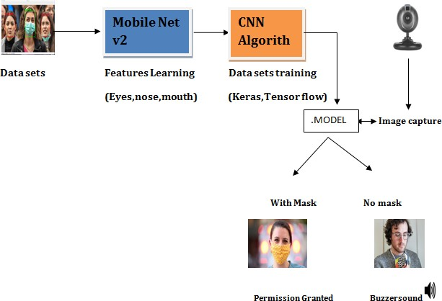

**Fig 1: Design of Face Mask Detector**

* 1. **Datasets**

This dataset, which is available on Kaggle, has three different classes which include

People who wear masks, people who do not wear masks. The dataset consists of 3542 images

of people wear masks, and 3846 images of people who do not wear a mask at all. The total

number of images for this dataset comes up to 7388 face images. Figure 9 shows sample images

of people who wear FM Figure 10 shows sample images of people who do not wear face masks.

Figure 11 shows sample images of people who wear face masks but in an incorrect manner. In

this dataset, people who wear face masks were labelled with class 0, while people who do

not wear face masks were labelled with class 1 and people who wear face masks

incorrectly were labelled with class 2. In this paper, this dataset was used for applying

the transferlearning method. Figure 12 displays a distribution of the total number of

different classes of the dataset. Likewise, figures 13, 14, and 15 present the distribution

of each class image size

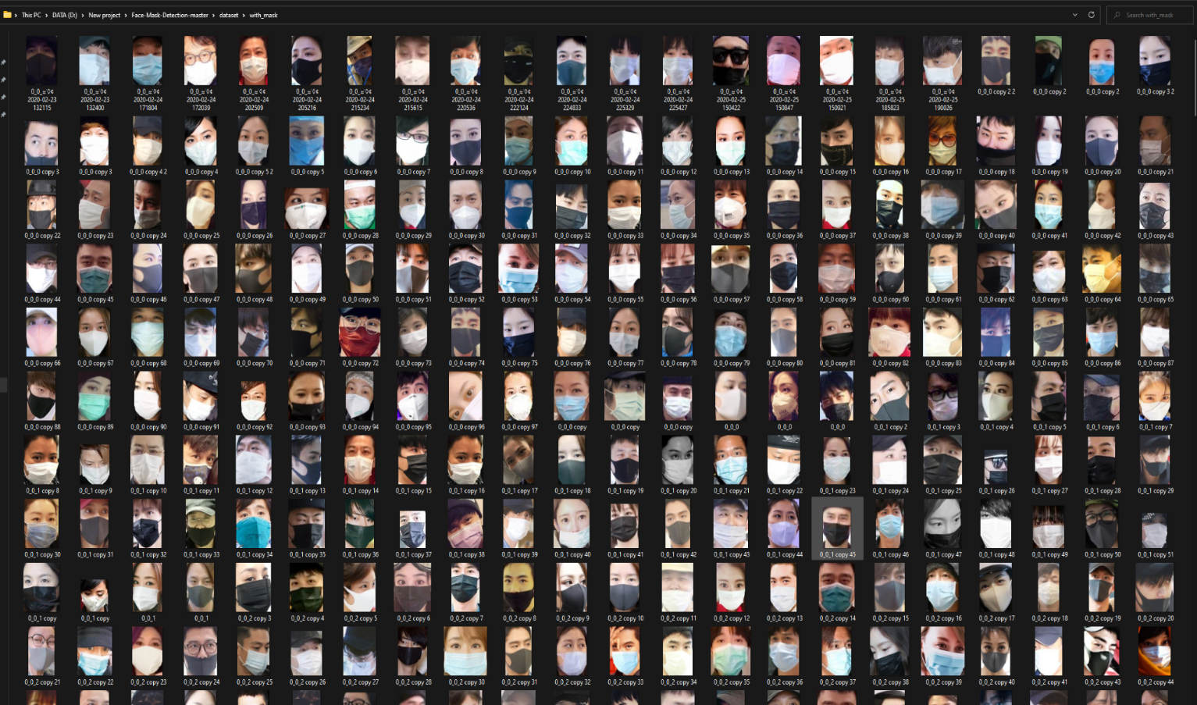

**Fig 2: People wearing Face Masks**

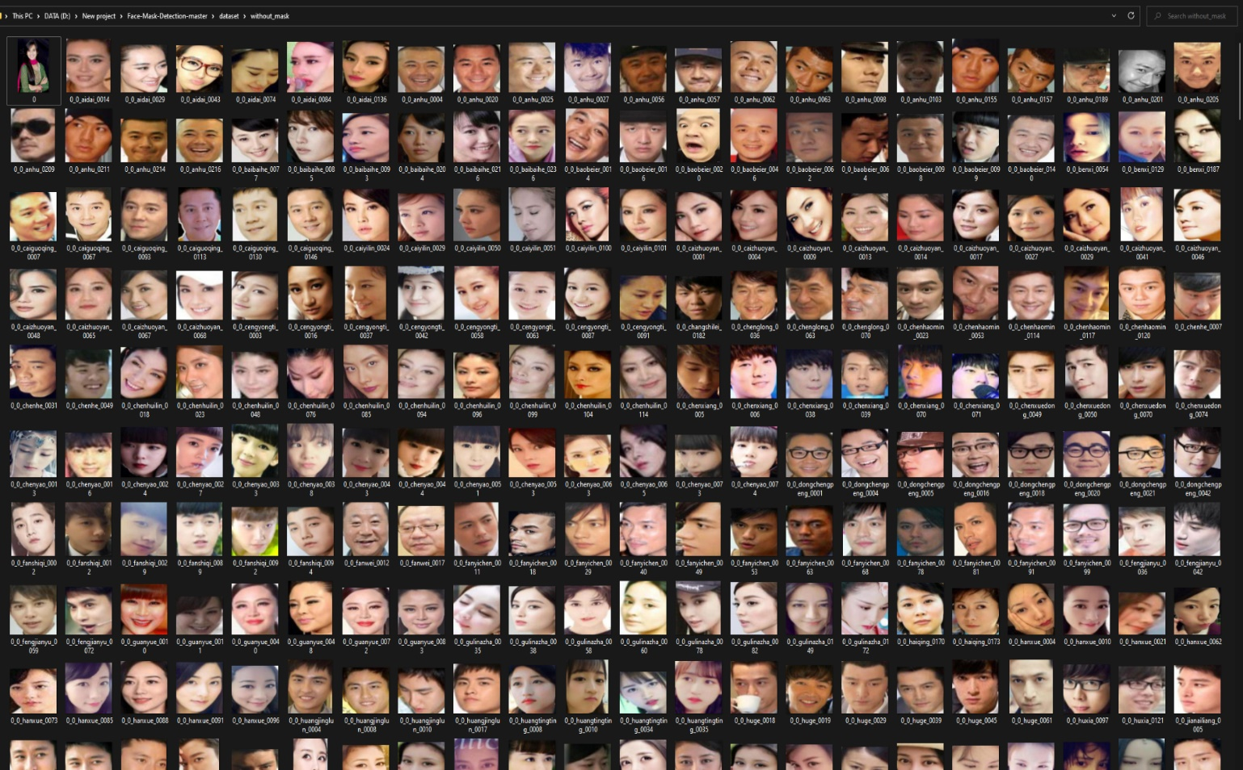

**Fig 3: People not wearing Face Masks**

* 1. **Development Platform Tools**

The following development tools are needed for the development of this project

1. **PYTHON Language**



**Fig 4: PYTHON Language**

Python is an interpreted, high-level, and general-purpose programming language. Python's design philosophy emphasizes code readability with its notable use of significant whitespace. Its language constructs and object-oriented approach aim to help programmers write clear, logical code for small and large-scale projects.

1. **Jupyter Notebook**

 **Fig 5: Jupyter Notebook**

JupyterLab is a web-based interactive development environment for Jupyter notebooks, code, and data. JupyterLab is flexible: configure and arrange the user interface to support a wide range of workflows in data science, scientific computing, and machine learning. JupyterLab is extensible and modular: write plugins that add new components and integrate with existing ones.

1. **GITHUB**



**Fig 6: GitHub**

GitHub, Inc. is a subsidiary of [Microsoft](https://en.wikipedia.org/wiki/Microsoft) which provides [hosting](https://en.wikipedia.org/wiki/Internet_hosting_service) for [software](https://en.wikipedia.org/wiki/Software_development) [development](https://en.wikipedia.org/wiki/Software_development) and [version control](https://en.wikipedia.org/wiki/Version_control) using [Git](https://en.wikipedia.org/wiki/Git). It offers the [distributed version](https://en.wikipedia.org/wiki/Distributed_version_control) [control](https://en.wikipedia.org/wiki/Distributed_version_control) and [source code management](https://en.wikipedia.org/wiki/Source_code_management) (SCM) functionality of Git, plus its own features. It provides [access control](https://en.wikipedia.org/wiki/Access_control) and several collaboration features such as [bug](https://en.wikipedia.org/wiki/Bug_tracking_system) [tracking,](https://en.wikipedia.org/wiki/Bug_tracking_system) [feature](https://en.wikipedia.org/wiki/Software_feature) requests, [task management,](https://en.wikipedia.org/wiki/Task_management) [continuous integration](https://en.wikipedia.org/wiki/Continuous_integration), and [wikis](https://en.wikipedia.org/wiki/Wiki) for every project.[[3]](https://en.wikipedia.org/wiki/GitHub#cite_note-hugeinvestment-3) Headquartered in [California](https://en.wikipedia.org/wiki/California), it has been a subsidiary of [Microsoft](https://en.wikipedia.org/wiki/Microsoft) since 2018.

* 1. **Libraries Used**
  + **Tensorflow:** TensorFlow provides a collection of workflows to develop and train models using Python or JavaScript, and to easily deploy in the cloud, on-prem, in the browser, or on-device no matter what language you use.

**Fig 7: TensorFlow**

* + **Keras:** Keras is an API designed for human beings, not machines. Keras follows best practices for reducing cognitive load: it offers consistent & simple APIs, it minimizes the number of user actions required for common use cases, and it provides clear & actionable error messages. It also has extensive documentation and developer guides.

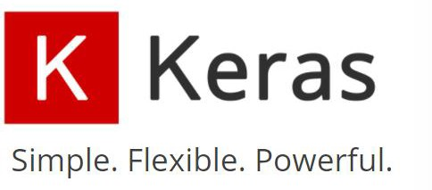

**Fig 8: Keras**

* + **Matplotlib:** Matplotlib is a comprehensive library for creating static, animated, and interactive visualizations in Python.

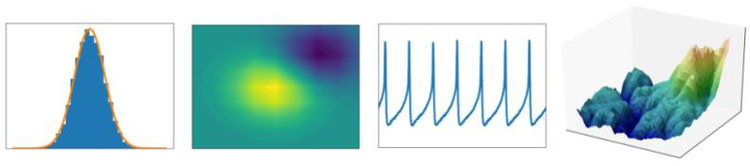

**Fig 9: Matplotlib**

Matplotlib produces publication-quality figures in a variety of hardcopy formats and interactive environments across platforms. Matplotlib can be used in Python scripts, the Python and IPython shell, web application servers, and various graphical user interface toolkits.

* + **Numpy:** NumPy is a Python library used for working with arrays. It also has functions for working in domain of linear algebra, Fourier transform, and matrices. NumPy was created in 2005 by Travis Oliphant. It is an open source project and you can use it freely. NumPy stands for Numerical Python.



**Fig 10: Numpy**

•

OpenCV was started at Intel in 1999 by Gary Bradsky, and the

**Open-cv:**

first release came out in 2000. Vadim Pisarevsky joined Gary Bradsky to

manage Intel's Russian software OpenCV team. In 2005, OpenCV was used on Stanley, the vehicle that won the 2005 DARPA Grand Challenge. Later, its active development continued under the support of Willow Garage with

Gary Bradsky and Vadim Pisarevsky leading the project. OpenCV now supports a multitude of algorithms related to Computer Vision and Machine Learning and is expanding day by day.

OpenCV supports a wide variety of programming languages such as C++, Python, Java, etc., and is available on different platforms including Windows, Linux, OS X, Android, and iOS. Interfaces for high-speed GPU operations based on CUDA and OpenCL are also under active development.

OpenCV-Python is the Python API for OpenCV, combining the best qualities of the OpenCV C++ API and the Python language



**Fig 11: OpenCV**

* 1. **Summary**

This chapter talks about the design part of the Face Mask Detector. And also about the

Datasets to train the model.

This chapter also talks about the system architecture of FMD in which a brief discussion is there for the total design of the FMD.

This chapter also talks about the development tools we need to improve and perform

the FMD also talks about the PYTHON libraries used in to train the model and detect

the face mask.

**CHAPTER 04**

**Training and Testing**

* 1. **Data Preprocessing**

In Machine Learning, Performing data pre-processing is a very significant step that helps in

Improving the quality of data to helpl the extraction of important understandings from the

data. In data pre-processing, the data is getting cleaned and organized to become proper for

building and training a model.

In this section we will convert all the images in the categories with and without mask into arrays to create a deep-learning model. Firstly with the help of keras.preprocessing.image we will load the images. Next we will set the height and width of the images (in our case 224 x 224px). Now with the help of img_to_array function we will convert the picture data into arrays. Here we create 2 arrays namely, data[ ] and label[ ]. In data[ ] we copy data of all the images and in label [ ] we add according to the category, with mask or without mask. With the help of binalizer() function from sklearn.model_selection we will convert the characters in label[ ] to binary values. Now the data[ ] and label[ ] should be converted into NumPy arrays as deep learning models only work with arrays. Next we will apply train_split_test function from sklearn.model_selection to train and test the images from data[ ] and label[ ]. We can change the percentage of images from the dataset to be used for training and testing.(In our case it is 80% and 20%)

* 1. **Supervised Learning**

Since supervised learning is that the best and most typical technique of machine learning

nowadays, during this paper, supervised learning techniques were accustomed succeed the

most effective performance results. supervised machine learning algorithms learn by example.

The term supervised learning comes from the conception of coaching the dataset. The

coaching dataset perpetually consists of input pictures, that also are perpetually combined with

their correct outputs. throughout the coaching method, any patterns within the knowledge that

relate to the chosen outputs are going to be examined by mistreatment the supervised learning

formula. when coaching, a supervised learning formula can absorb new unidentified inputs and

can be ready to determine the new inputs with their correct labels supported the preceding

coaching knowledge. the most purpose of a supervised learning model is to presume the right

label for recently conferred input file. A supervised learning formula as an easy equation that

may be seen in Equation one. during this equation, Y is that the foretold output and x is that

the input worth. This operate is employed in the main to attach input options to their foretold

output that is formed by the model throughout the coaching method.

Y = f(x)

*Equation 1: Supervised Learning Algorithm Equation*

* 1. **Transfer Learning**

Transfer learning is one among the machine learning techniques that works by reusing a pre- trained model that was originally engineered for one more dataset. Transfer learning then reuses that model as a start line for a replacement sometimes smaller dataset. Transfer learning is applied for dashing up the model’s coaching time and solve the matter of deficient information. Usually, whereas building the CNN models, tons of your time is spent on building and connecting convolutional layers. Transfer learning works by exploitation the previous neural network model to determine edges within the earlier layers, structures within the middle layer, and high-level options within the later layers. the first and middle layers are sometimes getting used, however the last layers ar solely retrained. Loading the new information set and applying data resizing, shuffling and grayscale conversion, fine-tuning was applied to boost the accuracy.

.

* 1. **Training and Fine-Tuning**

During the transfer learning process, fine-tuning was applied on the new dataset with a very

low learning rate. During this step, the previously constructed CNN model has been used

except the output layer. Thus, we need to adjust the output layer to the number of target

dataset classes for the new model. For example, in the approach, the initial pre-trained CNN

model, had three classes. Also during transfer learning, the learning rate was lowered to

0.0001. Figure 12 presents the fine-tuning procedures.

 

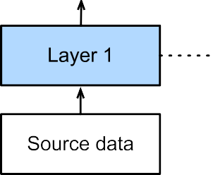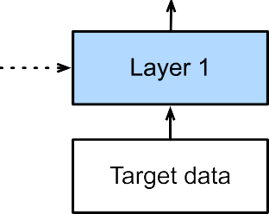

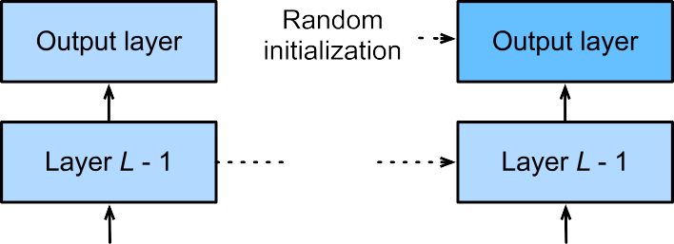

*Figure 12: Fine-tuning Steps*

After completing the fine-tuning step, the training step took place using face mask detector

dataset. During the training step, a batch size of 32 was applied to help the model faster

and improve the accuracy performance.

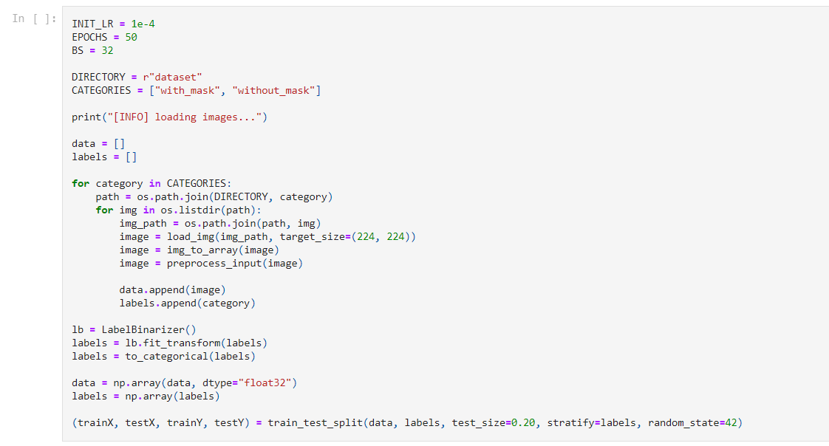

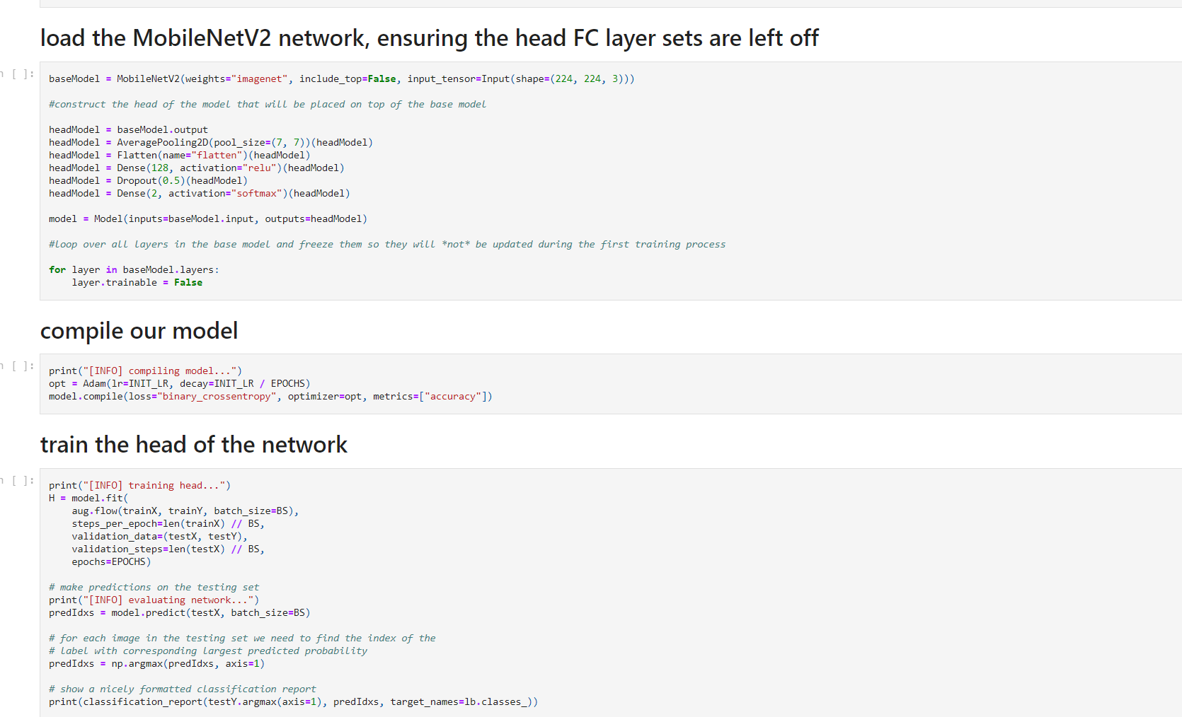 *Figure 13: Loading The datasets*

*Figure 14: Training and Compiling*

**4.5 Running Epochs and Accuracy**

An epoch refers to each cycle that a model takes through the full training dataset. For example, feeding the neural network with training data for more than one epoch, the result should become better in terms of predicting the given unseen data, which is the test data. In this approach, 30 epochs were applied to achieve the be st accuracy results of predicting the test data. Table 1

shows the impact of epochs on the loss percentage.

|  |  |  |
| --- | --- | --- |
| **Epoch Number** | **Percentage of Loss** | **Percentage of Accuracy** |
| **01** | **0.2419%** | **0.9316%** |
| **05** | **0.0612%** | **0.9826%** |
| **10** | **0.0434%** | **0.9871%** |
| **15** | **0.0399%** | **0.9883%** |
| **20** | **0.0347%** | **0.9889%** |
| **25** | **0.0277%** | **0.9901%** |
| **30** | **0.0272%** | **0.9910%** |
| **35** | **0.0253%** | **0.9915%** |
| **40** | **0.0227%** | **0.9910%** |
| **45** | **0.0211%** | **0.9920%** |
| **50** | **0.0204%** | **0.9929%** |
| **55** | **0.0220%** | **0.9922%** |
| **60** | **0.0224%** | **0.9917%** |
| **65** | **0.0178%** | **0.9934%** |
| **70** | **0.0162%** | **0.9939%** |
| **75** | **0.0171%** | **0.9940%** |

*Table 1: Epoch Number and Loss Percentage Results*

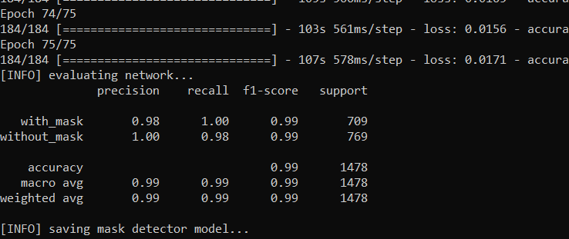

*Figure 15: Accuracy Results*

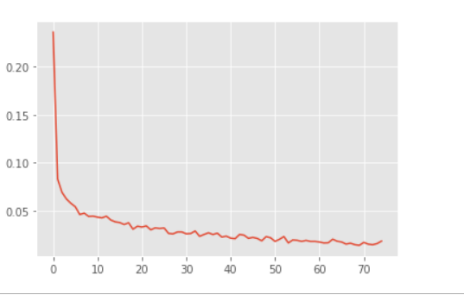

*Figure 16: Plot of results during Training*

**4.6 Testing**

For testing the face mask detector we need to load our pre-trained model from the output of

Training file and then we use our caffemodel file to detect and predict the face mask.

**CaffeModel File:**

A CAFFEMODEL file is a machine learning model created by Caffe. It contains an image

classification or image segmentation model that has been trained using Caffe. CAFFEMODEL

files are created from .PROTOTXT files.

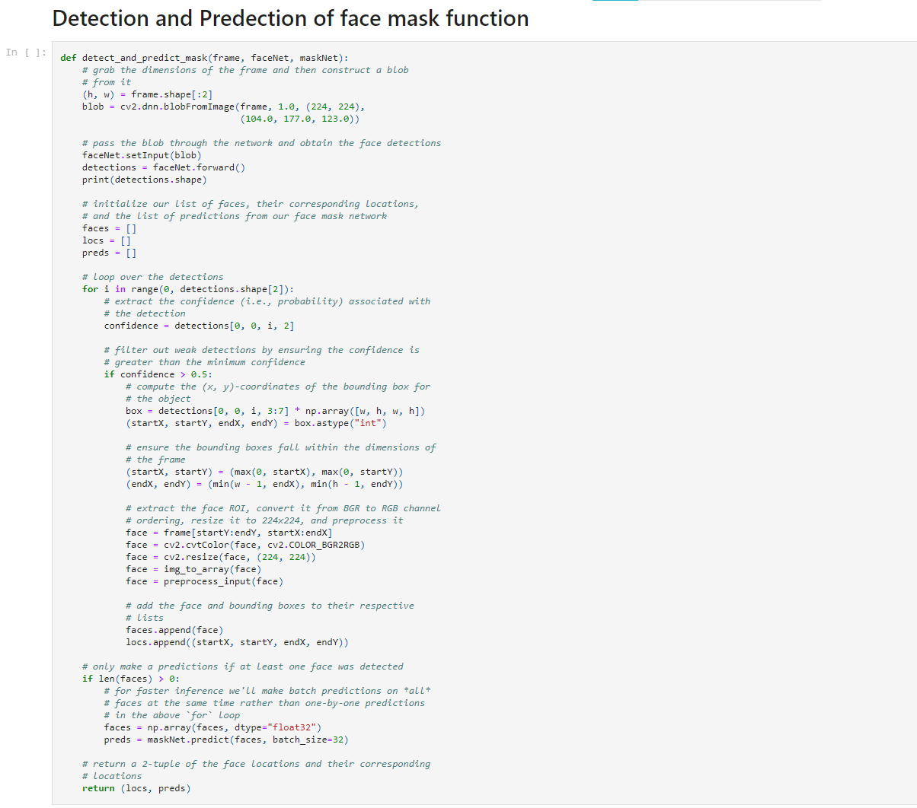

*Figure 17: Testing the Trained model*

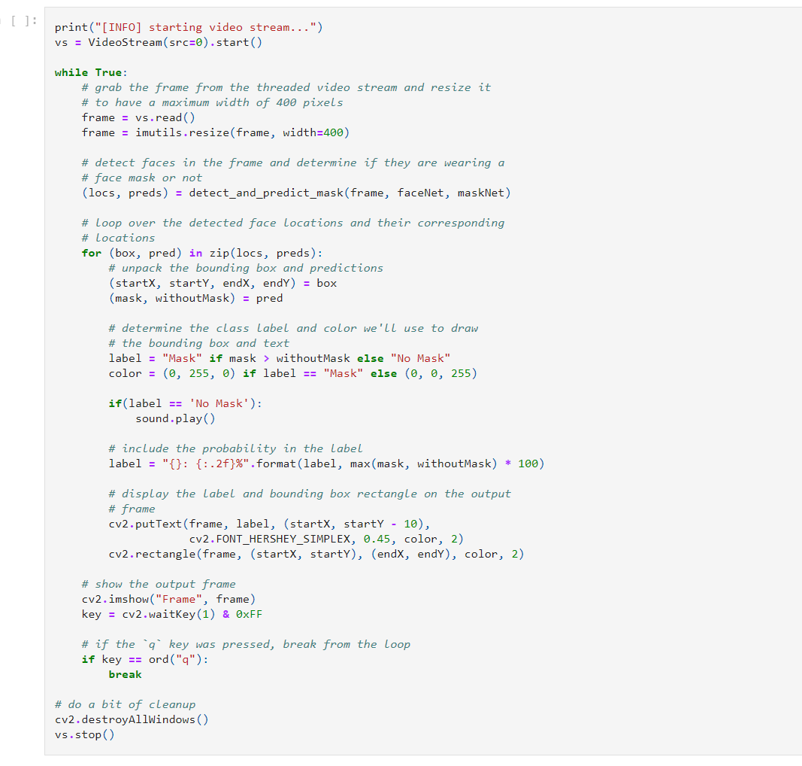

*Figure 18: Detecting the face mask using OpenCV*

**CHAPTER 05**

**Results and Discussions**

**5.1 Result on Testing**

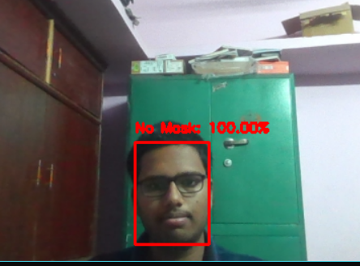

*Figure 19: Mask Detector Detecting with No Mask*

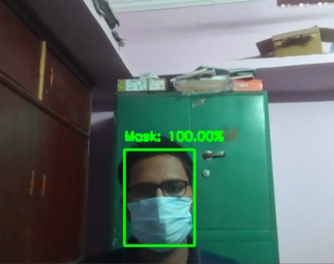

Fi*gure 20: Mask Detector Detecting with Mask*

**5.2 Some features of Face Mask Detector**

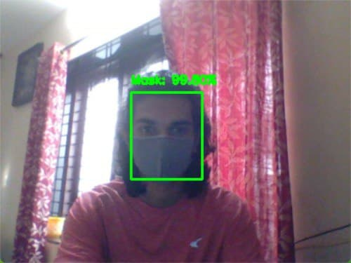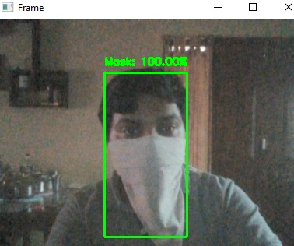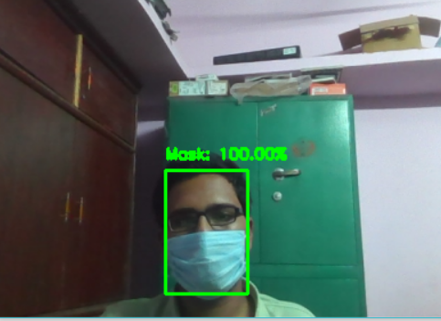

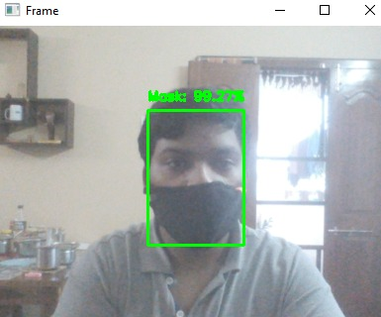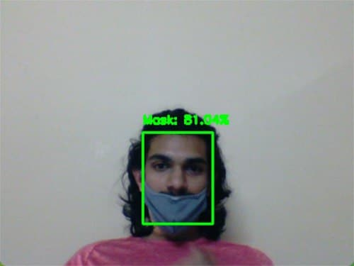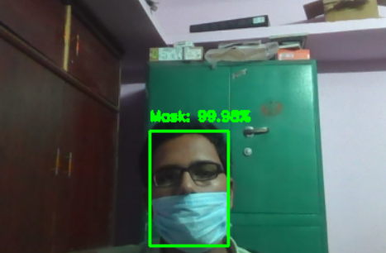

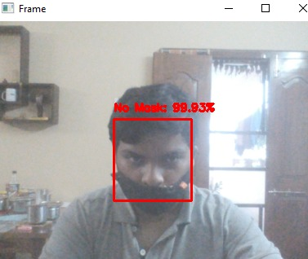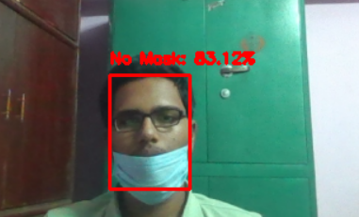

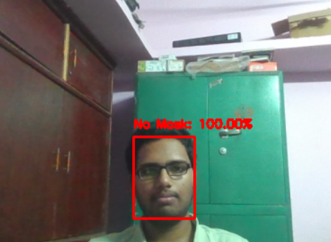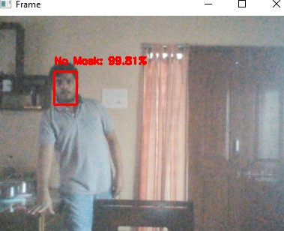

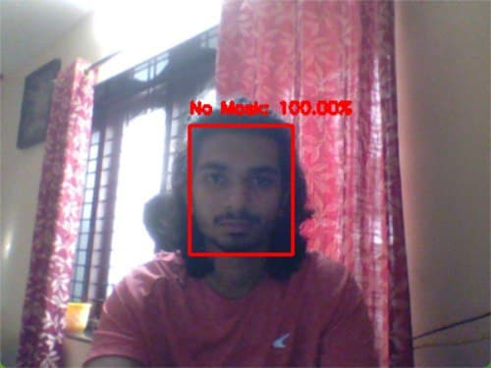

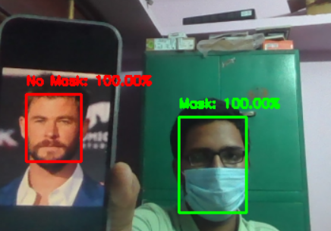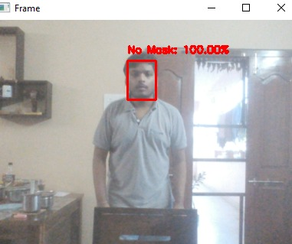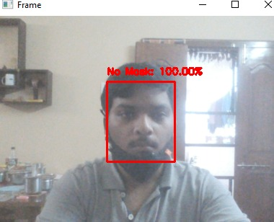

**5.3 Multiple Mask Detector**

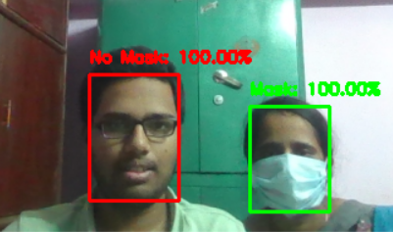

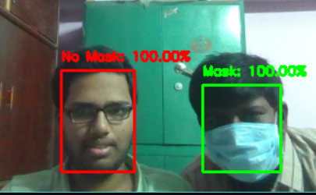

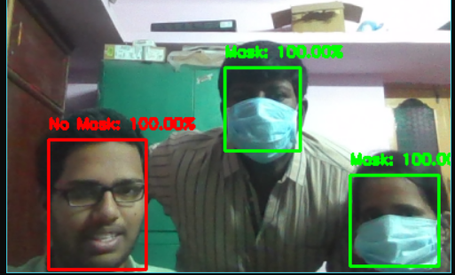

**Fail Case :**

The one failure of face mask detector is it can not work on the very low quality camera.

**5.4 Summary**

Results on Testing from above trained model . Testing is done for this project as automation for Face Mask Detector was not possible.

**CHAPTER 06**

**Conclusion and Future Scope**

**6.1 Limitations**

The identification of facemask- wearing conditions has multitudinous parallels to facial recognition. Still, the development of a facemask wearing condition identification network is challenging for several reasons. The limitations we have in the sector of datasets are one of

the most challenging issues to face. The size of facemask- wearing condition datasets comparatively smaller than general facial recognition datasets. And the image quality of these datasets are not as high enough, compared to generally available facial recognition datasets. Likewise, the various performances of wearing facemasks erroneously largely increase the difficulty of identification. There are a numerous limitations too our study.

Firstly, the dataset of Medical Masks which we used for face-mask wearing situation/condition identification is fairly small, and it can't cover all postures or

surroundings. Also, the dataset does not contain video, where the identification result on a

video aqueduct can't be tested. Another limitation is the devilish data loading time in

Jupyter Tablet while loading the dataset into it.

And one farther limitation in our Face Mask Sensor is low- quality cameras are not working properly. And the Camera should not be exposed to the light, it causes no discovery of mask. Let’s take a small illustration in the below image.

So also the camera is exposing farther light which is not fluently catch person’s face so that’s why the Mask Sensor is not detecting, since we didn’t train our model in that way.

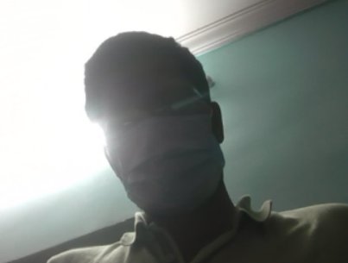So here the camera is exposing more light which is not clearly catch person’s face so that’s why the Mask Detector is not detecting, since we didn’t train our model in that way.

**Recommended Camera Settings:**

**Quality**: highest (minimum 720p is recommended for good prediction)

**Bitrate**: Maximum Possible

**Profile**: Maximum possible

**I-Frame Interval (GOV):** 50

**Stream anti-aliasing**: off

**Exposure and Brightness**: Ensuring that the face is clearly seen (if the camera faces light source, the overexposed background is unacceptable)

**Shutter Speed**: Must not be too low (more than 1/50), because in such a case the blurring of the moving objects will occur).

**6.2 Scope of the Project**

All around the world nearly more than 50 countries have lately initiated wearing face masks mandatory People have to cover their faces in public, supermarkets, public transports, services, and stores. Retail companies frequently use software to count thenumber of people entering their stores. They may also like to measure prints on digital displays and promotional defenses. We're planning to ameliorate our Face Mask Detection tool and release it as an open- source design. Our software can be equated to any being USB, IP cameras, and CCTV cameras to descry people without a mask. This discovery live videotape feed can be enforced in web and desktop operations sothat the driver can see notice dispatches. Software drivers can also get an image in case someone isn't wearing a mask. Here we are arranging an alarm system which will produce high intensity buzzer sounds when a person is not wearing a face-mask or properly not wearing a face-mask when they get detected by the system. This software can also be connected to the entrance gates and only people wearing face masks can go through the entrance.

**6.3 Future Goals**

* + - Integrate with the voice system
    - Mask Detecting with very low-end camera
    - Creating an Android Application.
    - Upper Clothes Colour detection (like a blue shirt)
    - Identity Detection

**References**

1. Chavez, S.; Long, B.; Koyfman, A.; Liang, S.Y. Coronavirus Disease (COVID-19): A primer for emergency physicians. Am. J. Emerg. Med. 2020. [CrossRef] [PubMed].
2. Cowling, B.J.; Chan, K.H.; Fang, V.J.; Cheng, C.K.; Fung, R.O.; Wai, W.; Sin, J.; Seto, W.H.; Yung, R.; Chu, D.W.; et al. Facemasks and hand hygiene to prevent influenza transmission in households: A cluster randomized trial. Ann. Intern. Med. 2009, 151, 437–446. [CrossRef] [PubMed].
3. Jefferson, T.; Del Mar, C.B.; Dooley, L.; Ferroni, E.; Al-Ansary, L.A.; Bawazeer, G.A.; van Driel, M.L.; Nair, S.; Jones, M.A.; Thorning, S.; et al. Physical interventions to interrupt or reduce the spread of respiratory viruses. Cochrane Database Syst. Rev. 2011, CD006207. [CrossRef] [PubMed].
4. Sim, S.W.; Moey, K.S.; Tan, N.C. The use of facemasks to prevent respiratory infection: A literature review in the context of the Health Belief Model. Singap. Med. J. 2014, 55, 160–167. [CrossRef].
5. Jefferson, T.; Foxlee, R.; Del Mar, C.; Dooley, L.; Ferroni, E.; Hewak, B.; Prabhala, A.; Nair, S.; Rivetti, A. Physical interventions to interrupt or reduce the spread of respiratory viruses: Systematic review. BMJ 2008, 336, 77–80. [CrossRef].
6. Cristani, M.; Bue, A.D.; Murino, V.; Setti, F.; Vinciarelli, A. The Visual Social Distancing Problem. IEEE Access 2020, 8, 126876–126886. [CrossRef].
7. Elachola, H.; Ebrahim, S.H.; Gozzer, E. COVID-19: Facemask use prevalence in international airports in Asia, Europe and the Americas, March 2020. Travel Med. Infect. Dis. 2020, 101637. [CrossRef].
8. Lai, A.C.; Poon, C.K.; Cheung, A.C. Effectiveness of facemasks to reduce exposure hazards for airborne infections among general populations. J. R. Soc. Interface 2012, 9, 938–948. [CrossRef] [PubMed].
9. R. Gambler, "Facial Recognition Technology," United States Government Accountability Office, September 2020. [Online]. Available: <https://www.gao.gov/assets/gao-20-568.pdf>
10. Coolfire, "How U.S. Airports Use Facial Recognition," Coolfire Core Solutions, 29 November 2018. [Online].Available:https://www.coolfiresolutions.com/blog/airportfacial-recognition-technology/.
11. P. Nagrath, R. Jain, A. Madan, R. Arora, P. Kataria and J. Hemanth, "SSDMNV2: A real time DNN-based face mask detection system using single shot multibox detector and MobileNetV2," Sustainable cities and society, March 2021. [Online]. Available: <https://www.ncbi.nlm.nih.gov/pmc/articles/PMC7775036/#sec0085>.
12. S. V. M. a. N. V. Dionisio, "Real-Time Facemask Recognition with Alarm System using Deep Learning," IEEE Control and System Graduate Research Colloquium (ICSGRC), 2020 [Online]. Available: <https://ieeexplore.ieee.org/stamp/stamp.jsp?arnumber=9232610>.
13. S. R. B. a. J. S. Kumar, "Geometric shaped facial feature extraction for face recognition," 2016. [Online]. Available: <https://ieeexplore.ieee.org/document/7887965>.
14. T. P. o. A. PAI, "Understanding Facial Recognition Systems," 19 February 2020. [Online]. Available:<https://www.partnershiponai.org/wp-content/uploads/2020/02/Understanding-Facial-Recognition-Paper_final.pdf>
15. R. Materese, "NIST Launches Studies into Masks’ Effect on Face Recognition Software," NIST,4 August 2020. [Online]. Available:https://www.nist.gov/newsevents/news/2020/07/nist-launches-studies-masks-effect-face-recognition-software.
16. M. Burugupalli, "IMAGE CLASSIFICATION USING TRANSFER LEARNING AND CONVOLUTION NEURAL NETWORKS,"July 2020.[Online]. Available:https://library.ndsu.edu/ir/bitstream/handle/10365/31517/Image%20Classification%20Usi ng%20Transfer%20Learning%20and%20Convolution%20Neural%20Networks.pdf?seque nce=1
17. Z. Elhamraoui, "Fine-tuning in Deep Learning," Artificial Intellgence, 23 June 2020. [Online]. Available: <https://ai.plainenglish.io/fine-tuning-in-deep-learning-909666d4c151\>
18. https://[www.ijert.org/research/covid-19-facemask-detection-with-deep-learning-and-computer-](http://www.ijert.org/research/covid-19-facemask-detection-with-deep-learning-and-computer-) vision-IJERTCONV9IS05017.pdf/
19. https://[www.scribd.com/document/541008885/Facial-Recognition-and-Face-Mask-Detection-](http://www.scribd.com/document/541008885/Facial-Recognition-and-Face-Mask-Detection-) Using-Machine-Learning
20. https://digitalcommons.montclair.edu/cgi/viewcontent.cgi?article=1729